Contents

1. Clientele Information and Position 2

1.1 The Hershey Company 2

1.1.2 Proposition 3

1.2 Product Attributes 4

1.2.1 Target Product 4

1.3 Hershey’s in Singapore 5

1.4 Market Analysis 5

1.5 SWOT Analysis 6

1.6 Market Segmentation 8

1.6.1 Target Market Segment and Rationale 8

2. Past Advertising 9

2.1 Review on Past Advertising Efforts 9

2.2 Comparative Studies of Competitors’ Advertising Efforts 9

3. Our Proposed Advertising Campaign 10

3.1 Campaign Qualitative Objective 10

3.2 Campaign Quantitative Objective 10

3.3 Creative Brief 10

3.4 Campaign: Phase 1 11

3.5 Campaign: Phase 2 14

3.6 Estimated Cost of Advertising Campaign 17

3.7 Execution Timeline 19

3.8 Conclusion 19

4. Annex 20

Bibliography 20

Survey 20

Storyboard for TV Ad 33

# 1. Clientele Information and Position

## 1.1 The Hershey Company

The Hershey Company (Hershey’s) was founded in 1894, and till date it is the largest producer of chocolate in North America, earning more than $5 billion in revenue with a growing international reach.[1]

Hershey’s offers many iconic brands, of which the more popular ones in Singapore being: Kit Kat, Hershey’s, Hershey’s Kisses and Reese’s. Nearly all of the major retailers in Singapore, such as NTUC, Cold Storage, Carrefour and Giant carry at least one of the above brands.[2]

## 1.1.2 Proposition

Hershey’s has its core business in manufacturing chocolates and sugar confectionary products and relies mainly on its supply network of retailers and distributors in making its products available to the general public. The retailers and distributors decide which products to stock up on based on the consumer’s demand.

Our group’s marketing campaign would focus mainly on a marketing pull strategy based on advertising and promotions to build up the consumer’s demand in Hershey’s products leading to greater sales figure. Specifically, we aim to identify potential market segments to increase the market share of Hershey’s products and improving customer’s image of Hershey’s products, leading to a greater sustainable profit margin.

## 1.2 Product Attributes

Hershey’s offers many products to cater to different consumer’s needs. Each of these products encompasses unique attributes that meets consumers’ specific demands. While their main business involves manufacturing of chocolates and confectionary products, Hershey’s has also introduced other complimentary sideline items to stimulate sales and to generate revenue.

### 1.2.1 Target Product

In view of the vast variety of products offered by Hershey’s, our group has decided to select and focus on Hershey’s chocolate bar and Kisses in particular for our advertising campaign as these are the most favorable flagship products of Hershey’s[3]. We would thus like to further bolster the image of these two products, which would in turn help to increase the general likings of other Hershey’s product as well.

## 1.3 Hershey’s in Singapore

Gill Capital has obtained exclusive franchising rights from Hershey’s in Singapore, and recent development includes the opening of 3 Hershey’s boutiques at Tampines Mall, CityLink Mall and Resort World Sentosa. Our ad campaign in Singapore would thus be catered specifically to further bolster Gill Capital’s sales results.

## 1.4 Market Analysis

The leading competitors for Hershey’s are namely: Candy Empire, Candylicious and Cocoa Tree.

Figure 1.4 [4]

Based on figure 1.5, we see that Hershey’s stand out by having a relatively premium price and lesser variety as compared to its competitors. Even though Hershey’s seem to lack in variety of its chocolate offerings (does not sell chocolates of other brands), it makes up in terms of its memorabilia offerings which its competitors do not offer.

## C:\Users\u0806949\Desktop\presentation folder\presentation folder\SWOT.png

Figure 1.5

## 1.5 SWOT Analysis

|  |  |
| --- | --- |
| Strengths | Weakness |
| * Unique chocolate products and baking goods such as Hershey’s Syrup and Hershey’s cocoa. * Includes availability of non-chocolate products to cater to a wider range of consumers. * Offers apparels and secondary products such as scented candles and plush toys. * Easily identifiable packaging of popular products such as Hershey’s Kisses and Reese Cups. | * Hershey’s products are relatively more expensive than other chocolate brands. * No existing advertising efforts which may result in Hershey’s not being captured in consumers’ evoked set of chocolates. |
| Opportunities | Threat |
| * Use of newly-opened boutiques to build up brand positioning in Singapore. * Able to capitalize on success of Resorts World Singapore. * Due to the multi-cultural characteristics of Singapore, Hershey’s has the capacity to be innovative in coming up with local packaging themes such as red packaging for Chinese New Year. | * Existence of other boutiques that sell similar products. * As a non-essential product, economic slumps may result in drastic falling demand for chocolates. |

## 1.6 Market Segmentation

## 1.6.1 Target Market Segment and Rationale

Our group has decided to focus on children who are still schooling in primary school, aged 7 to 12. The rationale for our chosen target audience is that our group felt that children within this age group are more impressionable than children of other age group. In addition, primary school children would be able to share their opinions on Hershey’s with other children in school.

Primary school children today have taken to the Internet as one of their mediums of learning, and would thus be able to access our online advertising effort too.

Lastly, by focusing on young children, we hope to instill a sense of brand loyalty and liking at a young age, such that they would be our future long-term customers.

# 2. Past Advertising

## 2.1 Review on Past Advertising Efforts

There has been no prior advertising campaign by Hershey’s in Singapore, as Hershey’s predominant revenue stream stems mainly from retailers and distributors. In addition, it was only a recent event that Hershey’s has decided to expand into Southeast Asia. The Hershey boutique store in Singapore currently runs some minor promotional programs, mainly within the store itself. This includes having Reeses, Hershey Bar and Kisses mascots walking around and taking pictures with children. Furthermore, visitors to the store are encouraged to take pictures that can be pasted onto Hershey bars or the Hershey syrup bottle.

## 2.2 Comparative Studies of Competitors’ Advertising Efforts

According to our field studies, HarbourFront which is geographically close to Sentosa houses two other candy and chocolate boutique stores; namely Candy Empire and Cocoa Tree. In addition, Candylicious; which is a candy boutique store is also situated at Sentosa.   
Our group has identified the above boutique stores as our direct competitors as they too offer consumers a one stop confectionary shopping experience.

While there have not been any past advertising efforts by these stores besides the occasional promotions, their presence would reduce the efficacy of our advertising campaign as they offer an alternative place for consumer to shop at.

# 3. Our Proposed Advertising Campaign

Our advertising campaign would be separated into two distinct phases, with the first phase focusing on achieving our qualitative objective of the campaign. Upon forming favorable impression with our target audience, we would commence with the second phase, aimed at increasing sales figures at the Hershey’s boutique store.

## 3.1 Campaign Qualitative Objective

The qualitative objective is to increase the general liking of the brand among target audience by 10 percent within 2 months.

## 3.2 Campaign Quantitative Objective

Our quantitative objective would be to increase sales by 20 percent at the Hershey boutique store within 4 months.

## 3.3 Creative Brief

The advertising appeal for the campaign would be largely emotional. In our initial research, an advertising concept test was conducted with children to identify their preferences. The result has shown that a significant number of children have indicated favorable impressions over the Hershey’s Bear. Thus our campaign would be based on the bear as a personality symbol for the brand, evoking feelings of happiness, cuddliness and sweetness. Furthermore, children would be able to identify the Hershey’s Bear with Hershey’s chocolate products, thus increasing their retention of the advertisement.

The overarching theme for the advertising campaign would be, “Fun in the Sun!” The slogan is short and simple, and children in our target demographic can thus easily retain and recall the message. Children viewing the advertising message would also be enticed to join in the fun as the beach ambience in the background of the advertisement conjures images of a fun-filled Sentosa. This fundamental message will be communicated in a synergistic approach in all advertising materials.

## 

## 3.4 Campaign: Phase 1

By making use of the Hershey’s bear in all of our advertising material, we hope that it will trigger happy emotions in our target audience and this will then lead to an increase in the liking of the brand.

The core of our advertising campaign relies heavily on the use of outdoor media and television as we feel that our target demographic is best reached through these means as seen from our survey results. Nevertheless, other supportive media platforms and promotional tools will also be used to support the campaign.

### 

### Outdoor Advertising

Outdoor advertising, particularly transit advertising will form the key component in our campaign. This is supported by our survey, whereby a significant number of children take public transport on a regular basis. Moreover, the location of the outdoor advertising message is of paramount importance as it will enhance brand recall.

Outdoor posters will be placed on buses and at bus stops, with emphasis on those located along school zones. In addition, posters will also be placed inside MRTs and on train stations. This would allow for retention of the creative message through frequent exposure and would thus effectively increase the awareness of the Hershey’s brand.

In addition, it is important to place the posters on the pillars at the Sentosa Express Station, HarbourFront and even billboards along the driveway into Resorts World for families driving into Sentosa. This would serve as reminder advertising, keeping the Hershey’s brand together.

### Television

From our survey findings (Ref: Annex Survey), children in Singapore do spend a lot of time watching television. Local channels that target children and families are mainly Okto and Channel 5. From our survey, a large number of children watch the television during the 7 to 9pm time slot on weekdays, and during the 9am to 12pm time slot weekends. Hence the Hershey commercial will be placed on the prime time slots of these channels in order to reach out to as many of our target audience as possible. The television commercial allows the still images in the print and outdoor advertisement to jump to life. The blending of visual and audio imagery has the potential to further appeal to children emotionally. The central message of the campaign, “Fun in the Sun!” will appear at the end of the commercial in order to be more persuasive according to the recency effect. Although, the television advertisement would also reach a large number of children in a cost-effective manner, a major disadvantage would be the clutter. In response to this problem, the presence of our campaign in outdoor and print media would assist in the breaking out of the clutter and increasing recall especially among our target audience.

### Supporting Media

### Print Ads

Consumer magazines are effective as they have the capacity to reach their target audience specifically. The benefit of placing our advertisement on magazines is the high quality print and creative flexibility. As a result, the colorful Hershey’s posters would attract our target audiences' attention. Placing ads on children or family based magazines would effectively increase the overall exposure of the advertising campaign to children.

For our campaign, two posters will be placed in the following magazines, Young Generation Magazine[5] and WaWa in Kids World Magazine[6], as both are fun and educational magazines that are popular with our target group. The posters will appear in full page spreads on alternate pages. The visual image of the Hershey’s Bear with the product will play a dominant role and occupy a majority of the entire advertisement space. The headline for the print advertisement would be the central theme of the campaign, “Fun in the Sun!”

### Online Media

In line with the objectives of an integrated marketing campaign and our survey findings, we feel that it is essential to set up a local based website for Hershey's Chocolate World, Singapore. A website dedicated to the Hershey's brand could be an interactive avenue in which children can learn more about the company and get updates on sales and promotions. All advertisements will feature the website address, thus driving consumers to visit the site.

Some possible avenues in which children can engage with the website could be to send a personalized message through the Hershey’s Kiss. Children could even download wallpapers for their desktops with the Hershey’s bear and Hershey chocolate products in it. Furthermore, the website could be tied in with sales promotions at Hershey boutiques through print out coupons from the site. Children could also be encouraged to upload their Hershey’s moments onto the website gallery. The television commercial will also be uploaded on the website and YouTube for children to view them at their own leisure.

Hence, the internet opens up opportunities for our target demographic to interact and learn more about the Hershey’s brand, building brand equity. The internet thus plays an important supportive role in achieving both the quantitative and qualitative communication objectives.

### Cinemas

With the findings from our survey, movie theatre advertising would be a key component that provides direct access without much clutter to a significant group of our target audience. (Refer to Annex Question 13) According to our survey, majority of the children prefer watching cartoons at cinemas. Cartoons are light-hearted programs and it is linked to our personality symbol, the cute cuddly Hershey’s bear. Thus, our advertisements will be featured in selective movies rated “G” and “PG”, to reach out to our target audience.

### Evaluation of Phase 1 Campaign

### We will conduct post-campaign polls on a representative sample of children between ages 7 to 12, to determine the percentage of children who have formed favorable impressions towards the Hershey’s brand after the conclusion of the campaign.

## 3.5 Campaign: Phase 2

Phase 2 of the campaign will commence after the successful conclusion of the Phase 1. Through this phase, we aim to create incentives for target audience to make purchases, thus increasing sales. The strategy to augment the sales rates in all boutique stores would be to capitalize on the established appeal of the Hershey’s bear and the favorable impression of the brand.

The key approach to increase sales revenue would be through sales promotions and the PR event; Golden Hershey’s Bear Ticket. Supporting promotional campaigns such as Singapore Hershey’s website would also be tied in.

### Sales Promotion

Our advertising campaign will include sales promotion strategies mainly on consumer franchise building promotions, to provide incentives for our target audiences to make purchases thus stimulating immediate sales. Hence, for a period of 1 month, with a minimum of $20 spent on a single receipt, children will be offered a cute miniature limited edition Hershey’s Bear key chain with a tag that reads, “Fun in the Sun!” This premium would be offered at a low price of $1 to encourage the children to buy and take home with them their own little Hershey’s Bear. The promotion would also only last for a short time in order to drive children to quickly make purchases to get the limited edition bear. Lastly, the keychain helps to further reinforce the children's association between the Hershey’s Bear and the Hershey’s brand, building brand equity and also increasing their retention of the association.

### Public Relations

The Golden Hershey’s Bear Ticket is not only aimed at increasing the news coverage of the Hershey’s brand, but is also tied in to our communication objectives. Through this event, we hope to enhance the public image of the Hershey’s brand in Singapore, forming a strong awareness and fondness of our brand among our target audience. In addition, we also expect to increase the patron figures at the Hershey’s boutiques.

Over a 3 month period, we plan to launch 3000 special edition Hershey's chocolate bar in the 3 Hershey’s boutiques in Singapore. Each chocolate bar would contain a lucky Hershey’s Bear ticket which gives children the opportunity to have fun in the sun. 3 Gold tickets will offer a 2 Day and 1 Night stay at Siloso Beach Resort with Sentosa Day Play Passes for a family of four which allows access to all 13 Sentosa attractions. 50 Silver tickets will entitle winners to 4 Sentosa Day Play passes and 200 Bronze tickets entitle a family of four to Noon Play passes. All other special Hershey chocolate bars will contain tickets that offer $5 off for the next $10 spent at the Sentosa Boutique store. The prizes however can only be claimed at the Sentosa Hershey boutique as part of efforts to entice children to come visit the store. Hence, the incentive to win the attractive Golden, Silver and Bronze ticket would help fuel the campaign centered in Sentosa.

In addition, a percentage of sales proceeds would go towards Canossaville Children’s Home, Singapore. The home aims to provide children with emotional and psychological support using promotional and preventive approaches. Hence, with the PR campaign, children purchasing the special edition Hershey’s chocolate bar not only stand a chance to win prizes but also get to help other children in need. This would thus create good publicity for Hershey’s and further drive up sales as parents would be more willing to purchase the chocolates.

### Supporting Media

### 

### Online Media

In line with increasing the sales at the Hershey’s store, we will be launching an interactive game on the website around the Hershey’s bear and the slogan, “Fun in the Sun!” Children would thus be encouraged to play the game which is relatively challenging to earn points. They can then print out their scores and every 100 points earned gives them a 20 percent discount on any purchase at the Sentosa boutique store. This promotion would appeal widely to children as they are enticed to have a go at the game. In addition to challenging other children’s high scores, they are also rewarded with discounts which would encourage them to make more purchases at the store. This also increases brand equity among our target audience.

### Evaluation of Phase 2

### In order to evaluate the promotional elements, we will monitor the sales rates throughout the Phase 2 campaign. Within the first month, we will also keep track of the number of premiums sold and as for the PR campaign, we will be carefully monitoring the return of investment.

## 3.6 Estimated Cost of Advertising Campaign

**Table 1**

|  |  |  |
| --- | --- | --- |
| Advertisement | Cost per month | Total Cost |
| Outdoor Ads   * Buses (135) * Bus stops * MRT stations | $5,000 per double decked bus  $80,000  $90,000 (Estimate) | $5,000 x 135=$675,000  $80,000  + $90,000  = $845,000  $845,000 x 2 = **$1,690,000** |
| Magazine Ad   * 2 full-page spread on alternate pages (No preference on exact location in magazine) | Singapore Child Magazine: $5,000 (Estimate)  Young Generation Magazine:  $4,800  WAWA Magazine:  $5,000 | $14,800 x 2 = **$29,600** |
| TV Ad   * 30 seconds on Channel 5 and Okto | $30,000  $30,000 | $30,000  + $30,000  = $60,000  $60,000 x 2 = **$120,000** |
| Website  - Interactive Game | $3,000 (estimate)  $1,500 | $3,000 + $1,500  **= $4,500** |
| Movie/Cinema Ad   * 30 seconds preshow commercial | $30,000 (estimate) | $30,000 x 2 = **$60,000** |
| PR campaign   * 3,000 bars of chocolate * Printing cost of tickets * Total cost of gifts   + 3 x 2D1N stay at RWS &  USS 1-Day Pass   + 50 x Day Passes to Sentosa   + 200 x Half-Day Passes to Sentosa | 3000 x $1.90=$5,700  $300  $43,372:   * 3 x $558=$1,672 * 50 x $243.60=$12,180 * 200 x $147.60=$29,520 | $5,700  $300  +$43,372=**$49,372** |
| Sales promotion   * Cost of miniature Hershey bear keychain | $300 (estimate) | **$300** |
| Miscellaneous cost   * Meetings * Printing of material * Transport | $1,000 | **$1,000**  **Total Overall Cost: $1,954,772** |

## 3.7 Execution Timeline

|  |  |
| --- | --- |
| Date | Event |
| 2nd May 2012 | Launch of Phase 1: outdoor transit advertising on Buses, bus stops, MRT and train stations  (Kisses, Hershey Chocolate bar) |
| 5th May 2012 | Magazine Ads |
| 9th May 2012 | Television Commercial |
| 12th May 2012 | Launch of Hershey Singapore website |
| 26th May 2012 | Commercial to be released on Cathay and GV cinema with Kung Fu Panda 2 movie |
| 18th July 2012 | Launch of Phase 2: Sales promotions at boutique |
| 18th August 2012 | Press Release on PR event |
|  |  |
| 15th September 2012 | Press Release on contributions/success of PR event |

## 

## 3.8 Conclusion

Based on our above ad campaign, we aim to fulfill both our qualitative objective of increasing the general liking of Hershey’s among our target audience by 10 percent and to fulfill our quantitative objective of increasing sales by 20 percent.

Through the fulfillment of our objectives, we hope to instill in our target audiences that Hershey’s is not just another supermarket product but a distinct product with its own unique characteristic. Hence we hope that kids can identify with Hershey’s as a niche brand in the overall competitive chocolate market.

# 4. Annex

## Bibliography

Carbon Disclosure Project 2010. Retrieved February 24, 2011 from The Hershey’s Company Website: <http://www.thehersheycompany.com/assets/pdfs/hersheycompany/cdp2010.pdf>

Chocolate Confectionary Singapore. Retrieved February 27, 2011 from Euromonitor International: [http://www.scribd.com/doc/47548141/Chocolate-Confectionery-Singapore Pg. 5-6](http://www.scribd.com/doc/47548141/Chocolate-Confectionery-Singapore%20Pg.%205-6)  
WaWa in Kids World Magazine. Retrieved March 18, 2011 from: <http://www.wawa.com.sg/images/wawaratecard.pdf>

Young Generation Magazine. Retrieved March 18, 2011 from: <http://www.panpaceducation.com/Library/docs/YG_Magazine_Advertising_Rates.pdf>

## Survey

Question 1: Total Surveyed

50

Question 2: Age group of respondents

7-8 years old: 8

9-10 years old: 19

11-12 years old: 23

Question 3: Gender

Female: 27

Male: 23

Question 4: What is your preferred mode of public transportation (able to choose more than 1 option)

Bus: 32

MRT: 42

Taxi: 5

Question 5: How often do you take public transportation?

All the time: 14

Frequently: 32

Sometimes: 14

Question 6: How many hours spent on television in a day?

Less than 1 hour: 3

1-2 hours: 28

2-3 hours: 14

3-4 hours: 5

Question 7: What time do you usually watch television?

9:00a.m-9:30a.m: 1

10:00a.m-11:30a.m: 2

7:00p.m-8:00p.m: 18

8:00p.m-9:00p.m: 15

9:00p.m-10:00p.m: 5

9:30p.m-10:00p.m: 5

10:00p.m-10:30p.m: 6

10:00p.m-11:00p.m: 3

Question 8: What are the channels watched on local television? (Choose more than 1 option)

Okto: 46

Channel 5: 32

Vasantham: 14

Channel 8:14

Suria: 14

Question 9: How often do you listen to the radio?

All the time: 5

Frequently: 5

Sometimes: 9

Rarely: 23

Never: 18

Question 10: Which of the following local radio channels you listen to?

Class 95fm: 23

Oli 96.8fm: 14

Symphony 92.4fm: 14

Gold 90.5fm: 5

987fm: 9

Question 11: Do you use the Internet at home?

Yes: 41

No: 9

Question 12: How often do you go to the cinema watch movies?

Frequently: 25

Sometimes: 19

Rarely: 6

Question 13: What type of movies do you watch at the cinema?

Cartoon: 46

Comedy: 14

Action/Adventure: 9

Others (Thriller): 5

Question 14: Scale of liking chocolates (1-10) [1 being the smallest, 10 being the greatest]

4: 9

5: 2

7: 7

9: 12

10: 20

Question 15: What you love about chocolates?

Taste: 47

Size: 18

Smell: 13

Packaging: 14

Question 16: How often do you eat chocolate in some form?

All the time: 11

Frequently: 18

Sometimes: 21

Question 17: Have you heard about chocolate brand, Hershey’s?

Yes: 37

No: 13

Question 18: Have you tried Hershey’s chocolates before?

Yes: 27

No: 23

Question 19: Do you like Hershey’s products? (only targeting at 27 children who have tried Hershey’s)

Yes: 18  
Some reasons: “tastes good”, “delicious”, “I like the milk taste”, “sweet and unique”, “tasty”

No: 9  
Some reasons: “too sweet”, “doesn’t taste that good”

Question 20: Do you like the bear in the picture below?

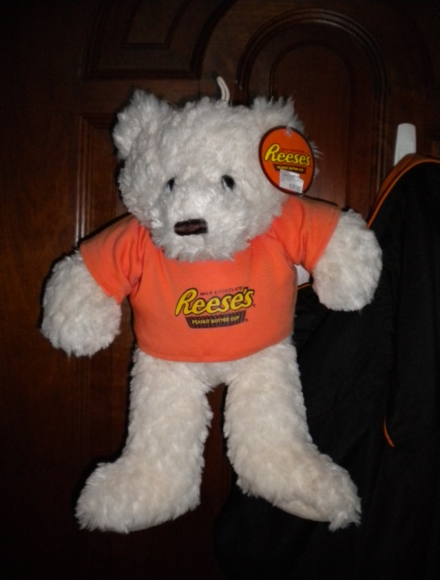

Yes: 42

Some reasons: “cute and fluffy”, “cute”, “soft and looks cuddly”, “looks nice”, “appealing”, “

No: 8

No particular reason

Question 21: Have you visited Hershey’s boutique shop in Resorts World Sentsoa?

Yes: 23

No: 27

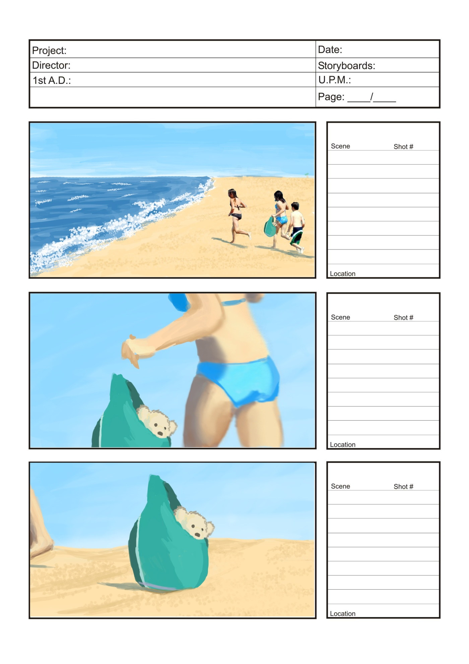

## Storyboard for TV Ad

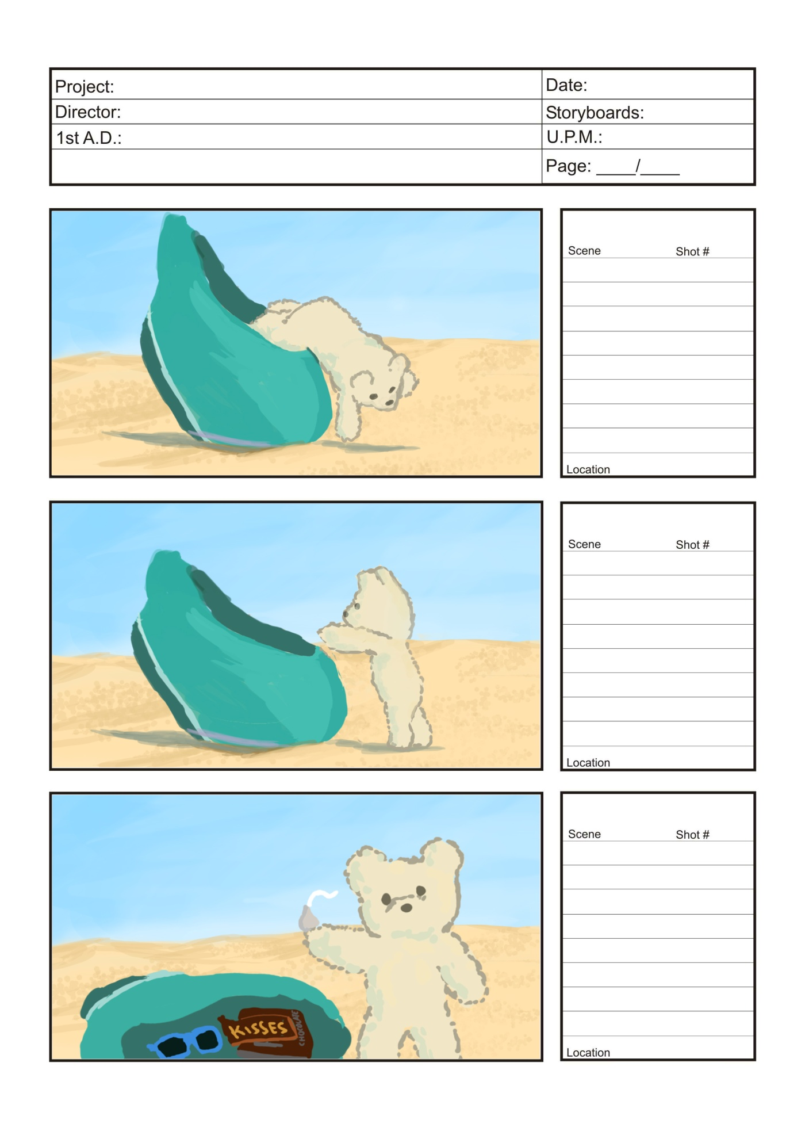

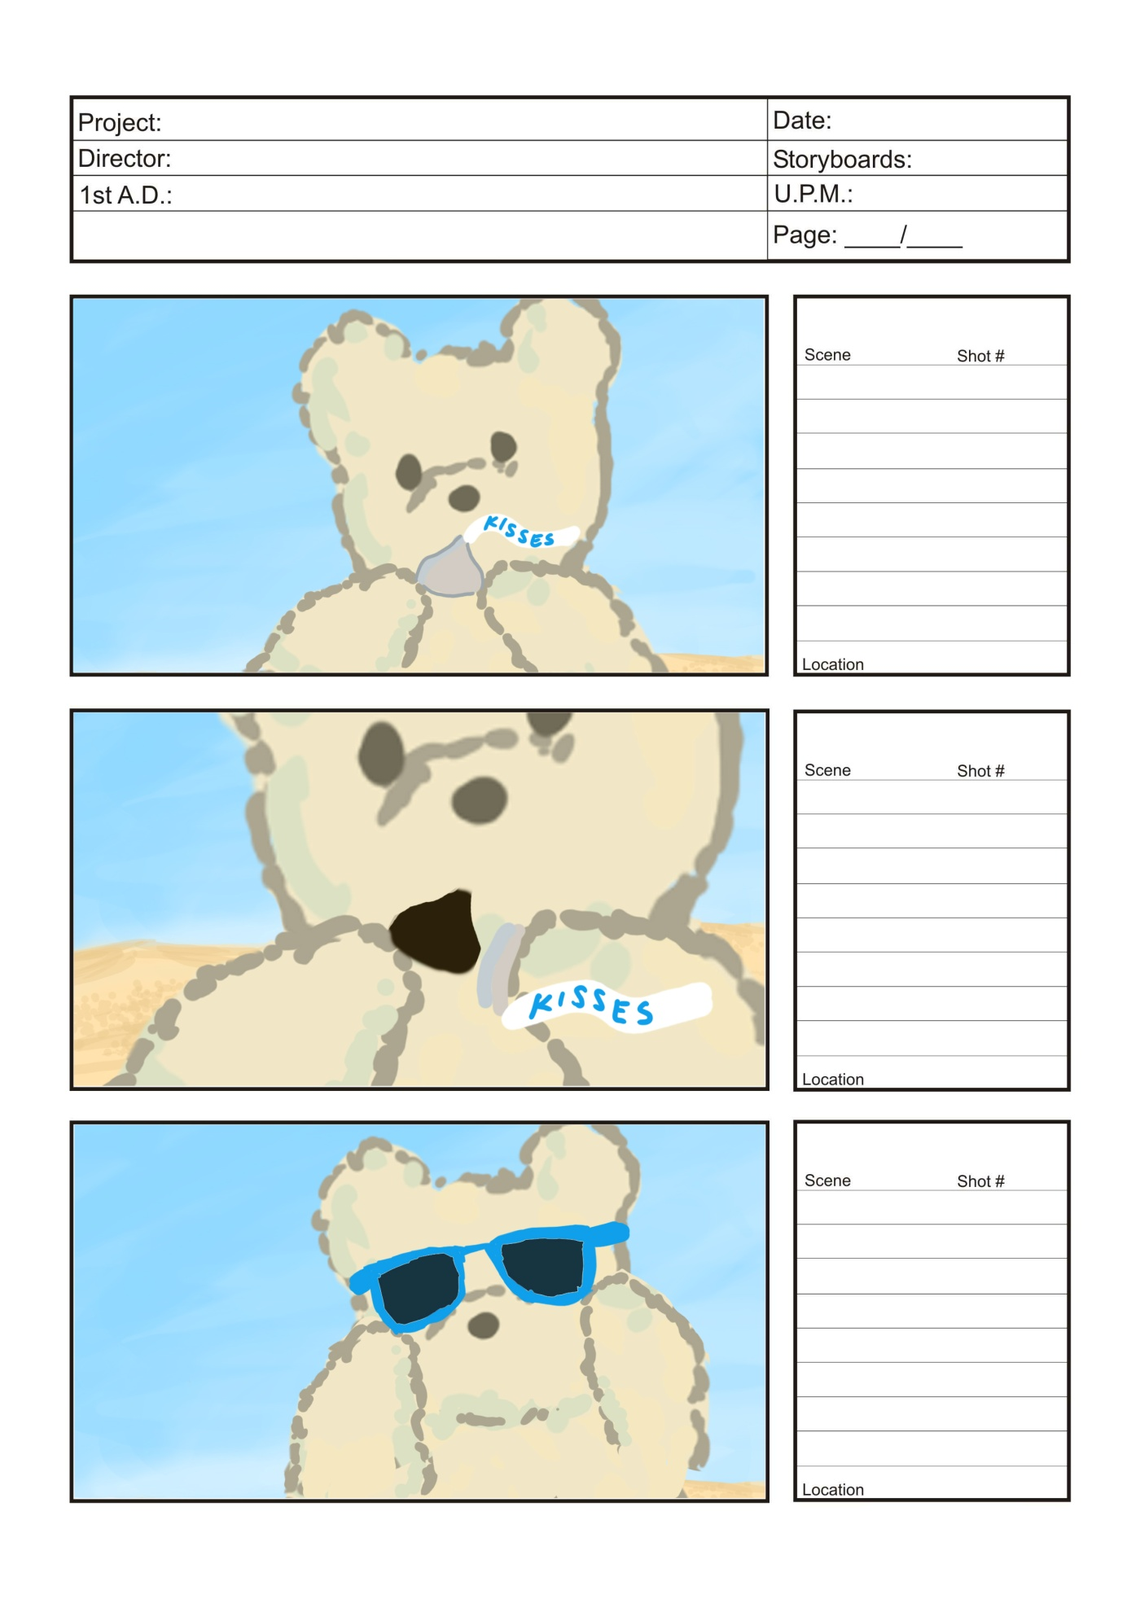

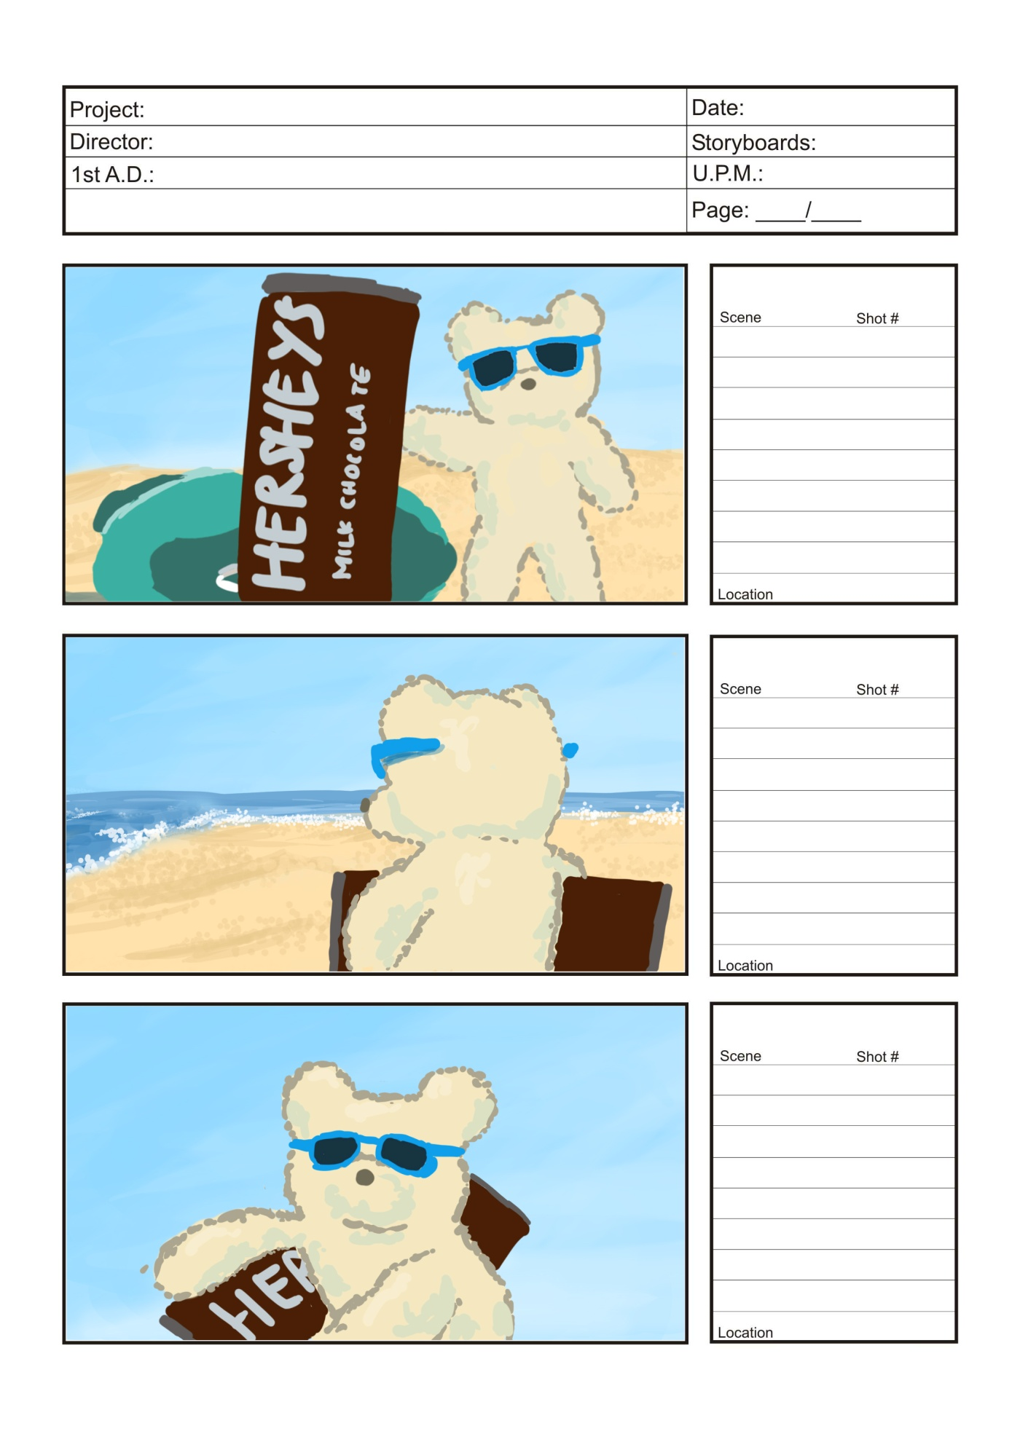

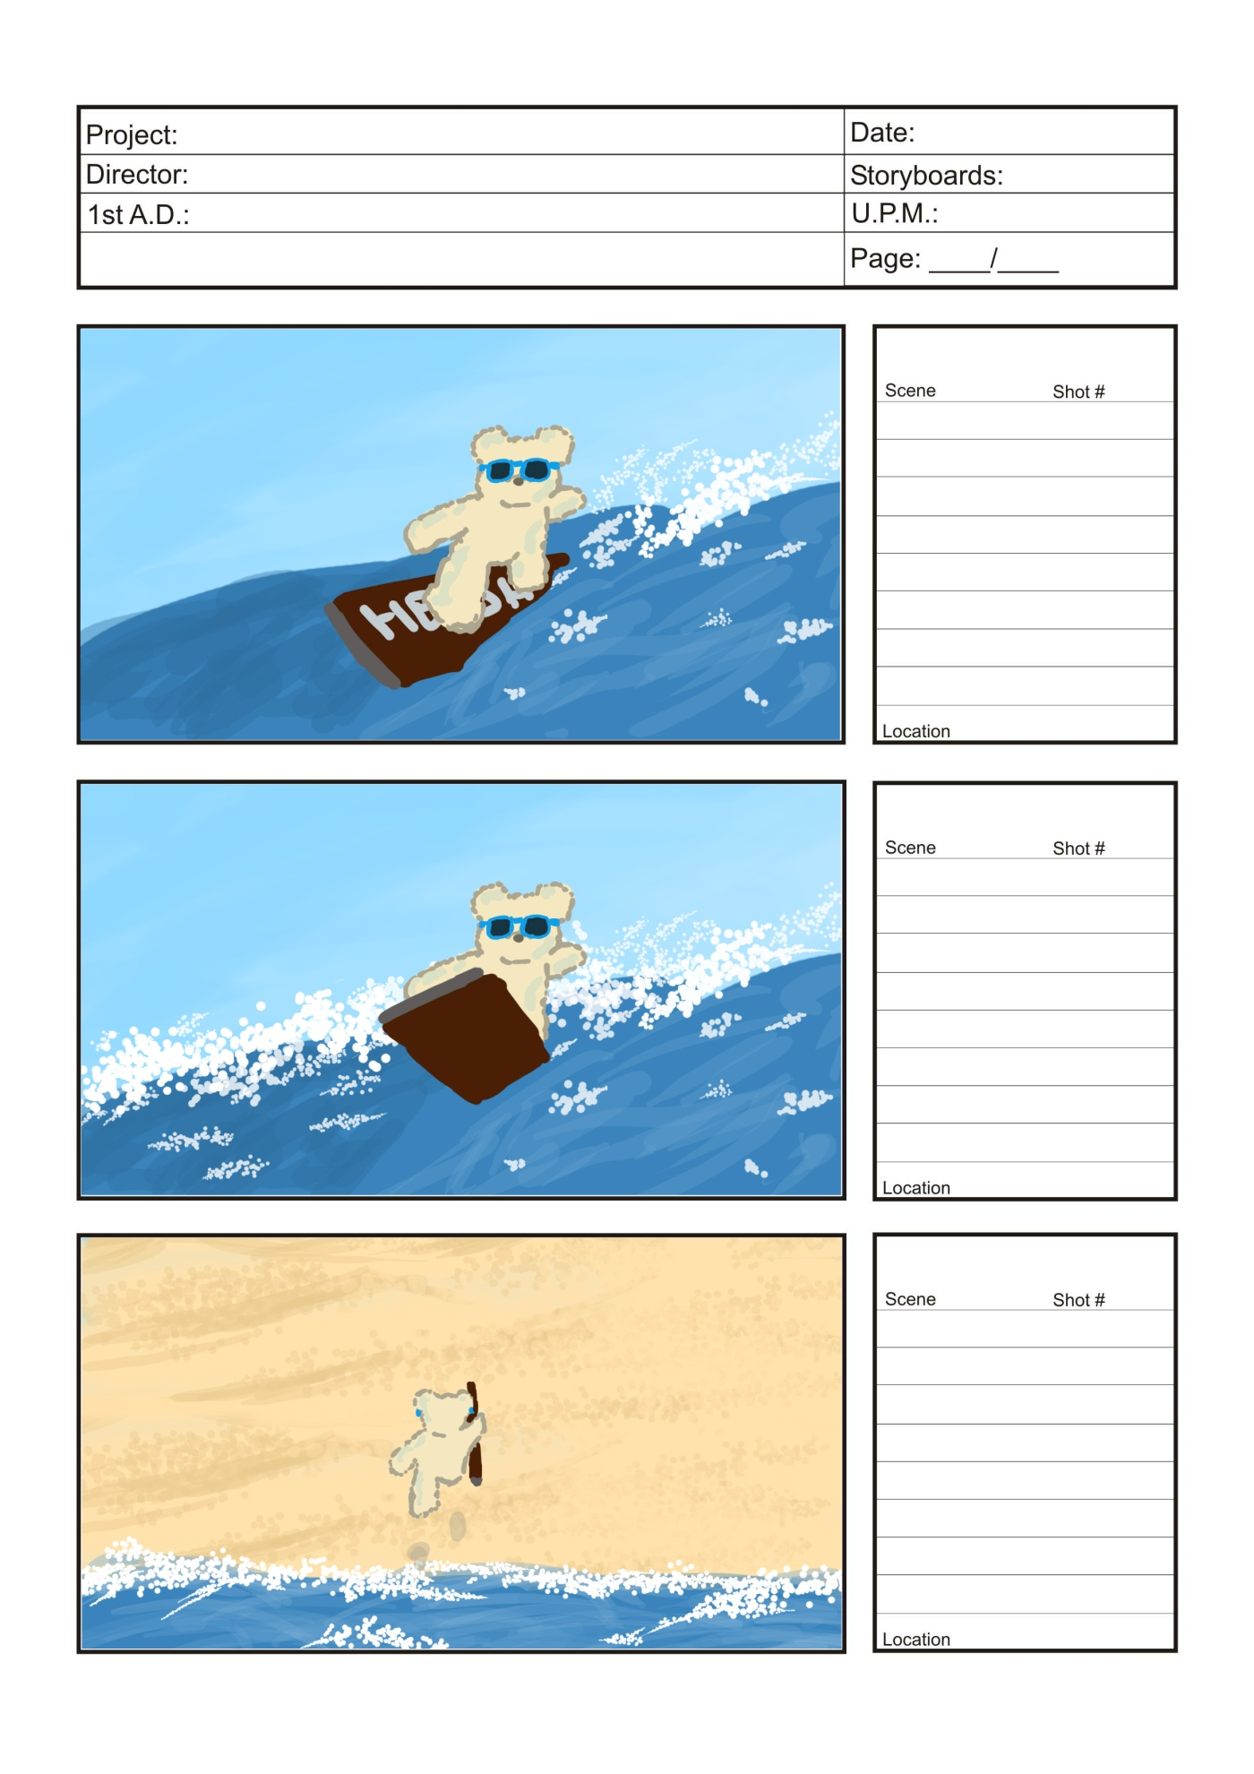

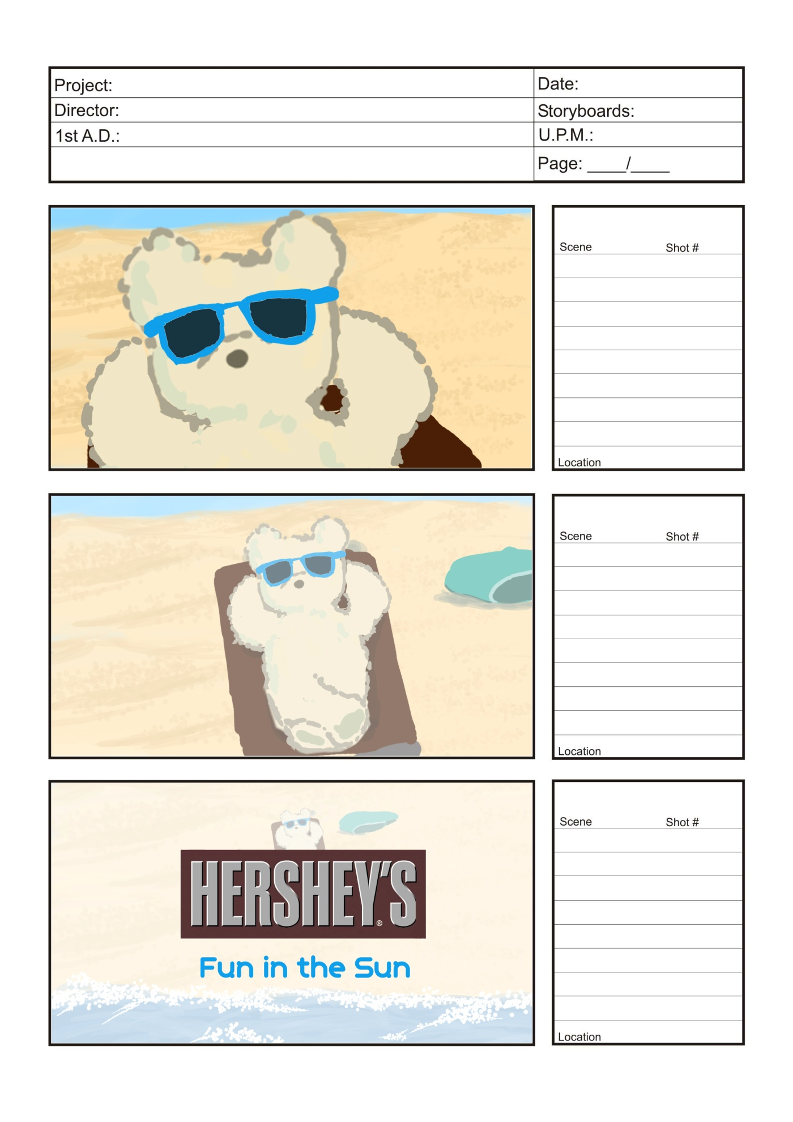

1. Carbon Disclosure Project 2010. Retrieved February 24, 2011 from The Hershey’s Company Website: <http://www.thehersheycompany.com/assets/pdfs/hersheycompany/cdp2010.pdf>
2. Chocolate Confectionary Singapore. Retrieved February 27, 2011 from Euromonitor International: <http://www.scribd.com/doc/47548141/Chocolate-Confectionery-Singapore> Pg. 5-6
3. Field studies conducted by our group, which includes interviewing the store manager, boutique staff and observing customers
4. Due to unavailable information, market share estimated based on number of boutiques for each company, and how long they have been in the market
5. Young Generation Magazine. Retrieved March 18, 2011 from: <http://www.panpaceducation.com/Library/docs/YG_Magazine_Advertising_Rates.pdf>
6. WaWa in Kids World Magazine. Retrieved March 18, 2011 from: <http://www.wawa.com.sg/images/wawaratecard.pdf>